**DESIGN AND IMPLEMENTATION OF AN ONLINE CASH REGISTER**

# TITLE PAGE

**BY**

**KUTUIJU KULDA**

**ST/CS/ND/21/096**

**DEPARTMENT OF COMPUTER SCIENCE,**

**SCHOOL OF SCIENCE AND TECHNOLOGY,**

**FEDERAL POLYTECHNIC, MUBI, ADAMAWA STATE.**

**IN PARTIAL FULFILLMENT OF THE REQUIREMENT FOR THE AWARD OF NATIONAL DIPLOMA (ND) IN COMPUTER SCIENCE.**

**SEPTEMBER, 2023**

# DECLARATION

I hereby declare that the work in this project titled “Design and Implementation of an Online Cash Register”was performed by me under the supervision of Mal. Usman Wakili. The information derived from literatures has been duly acknowledged in the text and a list of references provided. The work embodied in this project is original and had not been submitted in part or in full for any other diploma or certificate of this or any other institution.

Kutuiju Kulda ________________ _______________

(ST/CS/ND/21/096) Signature Date

# CERTIFICATION

This project titled “Design and Implementation of an Online Cash Register” meets the regulations governing the award of National Diploma (ND) in Computer Science, Federal Polytechnic Mubi, Adamawa State

Mal. Usman Wakili __________________

(Project Supervisor) Sign/Date

Mr. Mustapha Kassim __________________

(Head of Department) Sign/Date

Mal. Abdulrahman Saidu _________________

(External Examiner) Sign/Date

# DEDICATION

This project is dedicated to my beloved parents for their advice, encouragement and financial support towards my academic pursuit.

# ACKNOWLEDGEMENTS

I want to acknowledge Almighty God for his infinite mercy and protection throughout my academic activities. And for the understanding in achieving our academic success.

I also recognize my Supervisor Mal. Usman Wakili, who took time, despite his busy schedule to direct and guide me throughout this research work.

I also acknowledge the Head of Department Computer Science Mr. Mustapha Kassim for his moral encouragement throughout my period of study. I also acknowledge all Staff of Computer Science Department for their support and encouragement and the knowledge they’ve impacted on me throughout our studies.

I also want to appreciate my parents for their love and care and for giving me the opportunity to be trained and achieve my dreams.

Finally, I appreciate the efforts of my Uncles and aunties, for their encouragement and support throughout the course of my study and also my friends and relatives, course mates and all well-wishers. I love you all, may the Almighty God bless you abundantly, Amen.

# TABLE OF CONTENTS

TITLE PAGE i

DECLARATION ii

CERTIFICATION iii

DEDICATION iv

ACKNOWLEDGEMENTS v

TABLE OF CONTENTS vi

LIST OF FIGURES viii

CHAPTER ONE 1

INTRODUCTION 1

1.1 Background to the Study 1

1.2 Statement of the problem 1

1.3 Aims and Objectives 1

1.4 Significance Of The Study 2

1.5 Scope of The Study 2

1.6 Definition of Some Operational Terms 2

CHAPTER TWO 4

LITERATURE REVIEW 4

2.1 Introduction 4

2.2 History of On-line Cash Transaction 4

2.3 Concept of On-line Shopping 4

2.4 Concept of Computer Networking and The Internet 5

2.5 Internet Access 6

2.6 The Concept of Internet Gateways 6

2.8 The Merchant Account 7

CHAPTER THREE 8

SYSTEM ANALYSIS AND DESIGN 8

3.1 Disadvantages of The Existing System 8

3.2 Advantages of proposed System 8

3.3 Disadvantage of Existing System 8

3.4 The proposed Method 8

3.5 Method of Data Collection 9

3.6 System Design 10

3.7 Algorithm Design 11

3.8 System Architecture 12

3.9 Data base Tables/Quais Structure (Optionnel) 15

CHAPTER FOUR 20

RESULT AND DISCUSSION 20

4.1 Introduction 20

4.2 Source Codes 20

4.3 Sample Outputs 20

4.4 Web Development 21

4.5 Language Development/Selection 21

4.5 How to Run the Program 21

4.6 System Implementation 22

4.6 System Maintenance 27

CHAPTER FIVE 28

SUMMARY, CONCLUSSION AND RECOMMENDATIONS 28

5.1 Introduction 28

5.2 Summary 28

5.3 Conclusion 28

5.3 Recommendations 28

REFERENCES 30

# LIST OF FIGURES

Figure 3.1: Use case diagram - - - - - - - - 12

Figure 3.2: System architecture - - - - - - - - 13

Figure 3.3: Read News interface - - - - - - - - 13

Figure 3.4: Searched News interface - - - - - - - 14

Figure 4.1: Welcome Interface - - - - - - - - 15

Figure 4.2: Voice Controlled interface - - - - - - - 16

Figure 4.3: News Articles Interface - - - - - - - 16

Figure 4.4: News Article Interface - - - - - - - 17

ABSTRACT

*This project work is a computerization of the cash receipt generating system for a market. It entails maintaining database files of different sources of receipt whose scope and limitation are based on sales and purchases Receipts/Invoices inquiry on Total Balance and generation of report .But before we venture into that, attention should be drawn to the introductory part, the literature review and later the analysis of the existing system and the design of the new system. Since, there is constraint in time, this project will not go on exhaustive treatment of every expected module, rather will represent only sales and purchases receipt modules with two other operational modules subset of the broad menu .Nevertheless, there is provision for onward development of those expected modules and for other sources of receipts and other operations to suit any organization. It is not the intention here to treat each module separately hence the entire project is menu driven to cover some of the facilities present. Lastly, it is an optimistic fact that after going through the text, one would be able to know what is achieved having a clear knowledge of the project organization in relation to other sources and problems.*

# CHAPTER ONE

# INTRODUCTION

## 1.1 Background to the Study

Cash receipt generating system is a viable source in any business organization and venture and so on, its main purpose is to maintain more reliable records of money going in and out from the firm. This looks upon the view that the business organization must have business associates that exchange markets with each other. It is a sure fact that most have been a contract of which there is an obligatory task that stands the terms of agreement, it could be a payment to their client or partners or from their client who pays into their own account. Another thing matters whether it will be cash without remark balance or install mental, and how many installments it is going to be. Microsoft Encarta premium (2009) Internet Access technological

This is clear stated in the organization activities and manner of operation. Whenever there is payment, there is also the issuing of receipts that is centered on the writing of what each party has in stock.

In the processing components, we have Three Parts

1. System analysis
2. System design
3. System implementation.

None of these parts can be considered apart from the other two. To be courteous, I would say that the activities involved in system development are interlinked set.

## 1.2 Statement of the problem

Cash receipt system of Rorban Stores LTD is to keep records of all receipts of purchase and sales made, By doing so, they keep information concerning each transaction such as the name of client, address, data of transaction, description of goods. Quantity of goods, model number of the goods, the amount of the goods.

Inside this record the company can know the financial reports of both the client and the organization itself.

## 1.3 Aims and Objectives

This project is basically restricted to Rorban Stores LTD, as a case study for the project paper. Looking Rorban stores, the cash receipts system is restricted only to the.

1. Purchase receipts and/or invoice

2. Sales receipts and/or invoice

Other organizations may run a different receipts system. At this project paper we shall base only on sales and purchases.

## 1.4 Significance Of The Study

Out of this interview with the accountant and sales manager of Rarban stores LTD, I discovered that the organization does not keep any record on credits when purchases are made. Therefore the term paper nullifies the idea of computing credit in the purchase.

It will be right to say that Rorban stores do not go into purchasing on credit to avoid keeping many records that most often conflict matters.

## 1.5 Scope of The Study

There is a particular sales file for all buyers and dealers (companies that buy from them) that buy on cash. It also maintains a separate buyer’ sales creditors files, and a separate buyers'

sales debtors files, that is kept by the company. Therefore the term paper is basically on the above mentioned area as in sales. By this the company maintains one purchase database file and three sales database files, a total of four database files.

## 1.6 Definition of Some Operational Terms

**Acquiring bank:** This is a bank or financial institution that accepts payments for the product or services on behalf of a Merchant.

**Asp.net:** This is a powerful server side scripting language for creating dynamic and interactive websites.

**Computer:** This is an electro-mechanical device that is capable of accepting data as inputs, stores it, processes the data and outputs it as result or information.

**Credit card:** It is a payment mechanism that enables consumers to make their online purchase. {(Christopher M. and Chris F.K’s (2005)}

**Data:** Data are raw facts which undergo processing and become information. They are also the simplest unit of information that can stand on its own.

**Digital certificate:** It is a certificate that enables a merchant to do on-line business and it has been issued by a corporate body.

**Gateway:** This is a device that connects two computer networks that cannot be connected in any other way.

**Hypertext documents:** They are documents written with HTML, ASP, ASP..NET, PHP, JAVASCRIPT PAGES (JSP), CODE FUSION, PROGRAMMING LANGUAGES.

**Internet:** It is an interaction of computer networks connecting other networks from computers, companies, houses etc.

**ISP: (Internet Service Provider):**This is a company(s) that provides internet access to homes or business users.

**Merchant account:** It’s a contract under which an acquiring bank extends a line of credit to a merchant who wishes to accept payment card association brand

**Ms Sql:** This is a relational database server that is ideal for both small and large applications.

**On-line supermarket:** It is a representation of material or real shops on the internet or on the web.

**On-line shopping:** This is the buying and selling of products through the internet or web

**Program:** A program is a sequence of instructions written in a computer to execute a certain task and solve a problem. A program must possess clarity, be specific, effective and user friendly. Microsoft Encarta premium (2009) Internet Access technological.

# CHAPTER TWO

# LITERATURE REVIEW

## 2.1 Introduction

The review of literature discusses or deliberates on the inspection and examination of the various areas in this chapter that will appear or contribute in the writing of this project such as the concept of online cash transaction, concept of computer networking and the internet, internet access, concept of internet gateways, the world wide web and its benefits and the merchant account.

All these will in one way or the other be part of the breaking down of this project topic.

## 2.2 History of On-line Cash Transaction

This brief history of on-line POS receipt generation is taking its roots from the parent system which is E-commerce also known as electronic commerce. Online POS receipt generating is the buying and selling of products specifically over the internet. Unlike the general name E-commerce which involves buying and selling of all other goods and services. It is interesting to say that the relationship between them is that there is an exchange of goods instead of at the location of the store; it is conducted on-line and makes use of technologies such as electronic data interchange, E-mail, to keep track of transactions.

As history has it, at the close of the 20th century the bulk of Online POS receipt generating as a part of E-commerce transactions were retail transactions as security and encryption technology over the internet improved. It was affected by the explosive growth in E-commerce due to the expansion of the medium (internet) in the late 1990s.It almost moved faster than other segments of E-commerce transactions due to the ease and interest in people to be more knowledgeable. It spiced up the transactions in E-commerce because from the statistics E-commerce grew from $11.2 billion in 1998 to $31.2 billion in 1999, and in the year 2003, the transactions were predicted to grow to $380 billion. All these came to be as Online POS receipt generating started to become one of the fastest growing segments of E-commerce. As it is said, its transactions are business-to-business. Soon after then, companies like eBay created a new aspect of E-commerce which is the consumer-to-consumer transactions.

Conclusively, Online POS receipt generating as E-commerce became the ideal medium for markets to experiment with adjustments in their store environments and promotions to reach the most effective market target.

## 2.3 Concept of On-line Shopping

Literally, the word shopping denotes the activity of going to shops and buying things (0xford Advanced Learner's Dictionary).

According to Kiely T. (1997), On-line shopping is the buying and selling of goods or services on-line or via the internet or other networks. While Microsoft Encarta premium (2009) is of the opinion that it is the exchange of goods or services by means of the internet or other computer networks. This follows the basic principle of traditional commerce i.e the buyers and sellers coming together to exchange goods for money and profit. This concept provides an opportunity or avenue for consumers and retailers to communicate with each other and carry out their objectives i.e conduct business.

Rani Kalacota (1997) defined On-line shopping as part of an on-line business where consumers meet their suppliers for goods and services while Christopher M.H and Chris F. K (1994), defined On-line shopping as the process of managing on-line

financial transactions by individuals and companies. This however, includes business-to-business (B2B), business-to-consumer (B2C) and business-to-government (B2G) transactions. However, On-line shopping launches its focus on the systems or methods and procedures whereby all financial documents and information are exchanged. The on-line financial statements are not left out. According to Christopher M. and Chris F. K’s (2002) comments on this, on-line shopping is particularly concerned with the technologies that enable EPI systems to function well on the internet.

But Batty, J.B and Lee R.M. (1995) were of the opinion that there is no working and internationally recognized and agreed definition of on-line shopping. On-line shopping however has got to be defined with the three factors involved, which are the network which is the medium through which the relevant activities are carried out; the processes which are involved and to be included in the general domain of on-line shopping and lastly the actors which are the buyers or customers involved in the transactions.

## 2.4 Concept of Computer Networking and The Internet

According to Microsoft Encarta premium (2009), computer networking is simply a system used in linking two or more computers. Networking itself is a group of connected computers that allow people to share information and equipment. Computer networking uses a communication link or node through which the E-mails, files resources and other applications are sent and received. A computer system and a printer can both serve as communication links in a network. However, there are other devices. It has layers, and criteria, parts and connection types, topology and types of networks, network peripherals and areas of applications. All these computer networking processes must pass through to ensure effective on-line business.

Networks are specified through broad and narrow definitions. The broad definition considers an on-line transaction to be the sale or purchase of goods or services either between businesses, households, individuals, government, other private or public organizations.

The role of networking in on-line shopping is that of conveying, providing computer systems and other resources and connecting them for the on-line transactions.

The internet on the other hand is a computer based global information system. It is composed of many interconnected computer networks. Each network may link tens, hundreds or even more. The satellite systems are vital tools/equipment in the internet computer network. Its role is of paramount importance. It includes advertising the books, selling, buying delivery and providing other customer services.

Meanwhile, the narrow definitions of Batty J.B and Lee R.M (1995) have it that internet transactions (on-line shopping) to the sale or purchase of goods and services whether between businesses, households, individuals governments and other public or private organizations are conducted over the internet. The goods and services are ordered over the internet, but the payment and the ultimate delivery of goods or services may be conducted on or off line.

## 2.5 Internet Access

According to Microsoft Encarta premium (2009) Internet Access technology refers to the communication between residence or a business and the ISP (internet services provider) that connects them to the internet. They are of three types namely; dedicated, dial up and wireless internet access. It is therefore the communication that is going to exist between the customer, the ISP and the supermarket through the internet. It is all about the easy accessibility the customers will enjoy.

## 2.6 The Concept of Internet Gateways

The computer system hardware contains software that connects networks that use different protocols (the rules the hardware components and the software components use to communicate) or that transfers data between two incompatible applications on a network. It reformats data so that it is acceptable to the receiving network application. The term internet gateway is usually used to describe any computer that transfers data from one computer system to another.

**2.7 The World Wide Web and its Benefits**

This is the multimedia interface that connects us to resources or the customers to the documents, goods, services, e-mails, chats about the books and other websites available on the internet. The World Wide Web which is abbreviated www is the window from which we see the information on the internet.

It all began in 1992, prior to it, the internet was just ordinary text, documents without pictures, sounds or video, it is through the website that we will carry out the on-line shopping. The benefits accruing from the use of the World Wide Web are so numerous. To mention but a few, the ease it has given to people to send and receive messages to study and even purchase goods on-line and to know and see things and other people in other parts of the world.

## 2.8 The Merchant Account

According to (Duncan et al), a merchant account is a contract under which an acquiring bank extends a line of credit to a merchant, who wishes to accept payment card transactions of a particular card association brand. Without such a contract, one cannot directly accept payments by any of the major credit card brands. When using an intermediary payment services provider (such as paypal), the merchant account is held by the service provider itself. Here, the contract of the Acquiring bank with the merchant is informally referred to as a merchant account. It is rather a line of credit and not a bank account.

Under this contract, the acquiring bank exchanges funds with issuing banks on behalf of the merchant, and pays the merchant for the net balance of their daily payment card activity.

# CHAPTER THREE

# SYSTEM ANALYSIS AND DESIGN

This section of the project deliberates on the source of information about the current system organization and maintenance. The organizational chart, representing the organizational structure of the supermarket in a hierarchical order will be illustrated. The problems of this system will be outlined carefully.

Finally, the proposal of the system to be developed, its exploration, input and output specifications, requirements and the scope will be expressed.

## 3.1 Disadvantages of The Existing System

The main method of research concerning this project is by observation and interview with the supermarket members of staff. After frequent visits to the supermarket, it was easy to draw conclusions from some observations about the current system. Brief interviews with some customers who agreed having an idea of the online POS receipt generating system were also of great help to this project.

## 3.2 Advantages of proposed System

The Rorban supermarket is a supermarket like other supermarkets established with the aim of generating some worthwhile revenue through the sale of products and services to customers. The supermarket is located in owerri. Its missions are to provide customers with quality and edifying products and services for their use with ease at affordable prices.

## 3.3 Disadvantage of Existing System

It is a clear statement and a well-known adage that two heads are better off than only one. Hence the need for the research works.

Apart from the problems existing from being manned by one man, there are other problems, namely;

**1. Difficulty in Keeping Record of Products and daily Transactions:** Due to the quantity of products that come there, difficulty in keeping accurate records occurs.

**2 Time Wastage:** This problem results in a waste of time in sorting out products

3 **Poor Equipment:** There are little or no shelves or counters to keep products for easy reach and retrieval. It makes the whole hall untidy because products are scattered on the floor.

4 **Slow Services:** There is always a problem of slow service because of one shopkeeper.

## 3.4 The proposed Method

In the process of evaluating the solution and the specifications of a detailed on-line based solution, there is a need for the system design. In designing the new system, the software and hardware aspects were taken into consideration in order to produce a workable application that will allow effective and efficient communication between the customer, the merchant and the acquiring bank or acquirer.

Also the customer can make an order, make payments for the goods ordered, and the goods will be shipped to him/her with the receipt.

**Data Design:** This involves the choice of data structure and database. The application uses MYSQL server as the database. This sophisticated database allows the administrator to monitor effectively and run some query language in the server. It is equipped with maximum security to prevent hacking.

**User Interface Design:** It is a system that permits the interaction between human beings and the computer. The project has a user interface design because of the level of interaction the buyer or credit or mastercard wants.

**Procedural Design:** This involves the design of an efficient algorithm that will satisfy the functional description of the various sub systems of on-line shopping.

## 3.5 Method of Data Collection

In [software](http://en.wikipedia.org/wiki/Software_engineering) and [systems engineering](http://en.wikipedia.org/wiki/Systems_engineering), a **use case** is a list of steps, typically defining interactions between a role (known in [UML](http://en.wikipedia.org/wiki/Unified_Modeling_Language) as an "[actor](http://en.wikipedia.org/wiki/Actor_%28UML%29)") and a system, to achieve a goal. Below is the use case diagram of the Online POS Receipt Generating System.

**Use case Diagram**

Users

creates

Invoice

Has Items

Invoice Details

Sale

Product

N

N

N

1

1

1

## 3.6 System Design

This emphasizes on the purpose of the newly designed system so as to facilitate the operations of the shopping system. This system proposal here has come to scrutinize the old manual system, improve it and propose a new one which will prompt the supermarket to be more effective and efficient in their operations.

## 3.7 Algorithm Design

The purpose of this project is to design an on-line system where cashier; can make records on any products with reduced stress. The purpose of designing this system includes the following,

1. To be able to conduct business 24 x 7 x 365. That asserts that the system will operate 24 hours a day, 7 days of the week and 365 days of the year.
2. Access the global marketplace meaning that the internet spans the world and is possible to do business with any business man who is connected to the internet. This global opportunity is assisted by the fact that unlike traditional communication, user or business men are not charged according to the distance over which they are communicating.
3. Speed electronic communications always allow people to do their transactions faster without waiting for the shopkeeper to sort them out.
4. Strategic place here is this global market on the internet, students can easily go and make their orders without having to search long for it

## 3.8 System Architecture

The database designs that will be used to design the Online POS Generating System are shown below

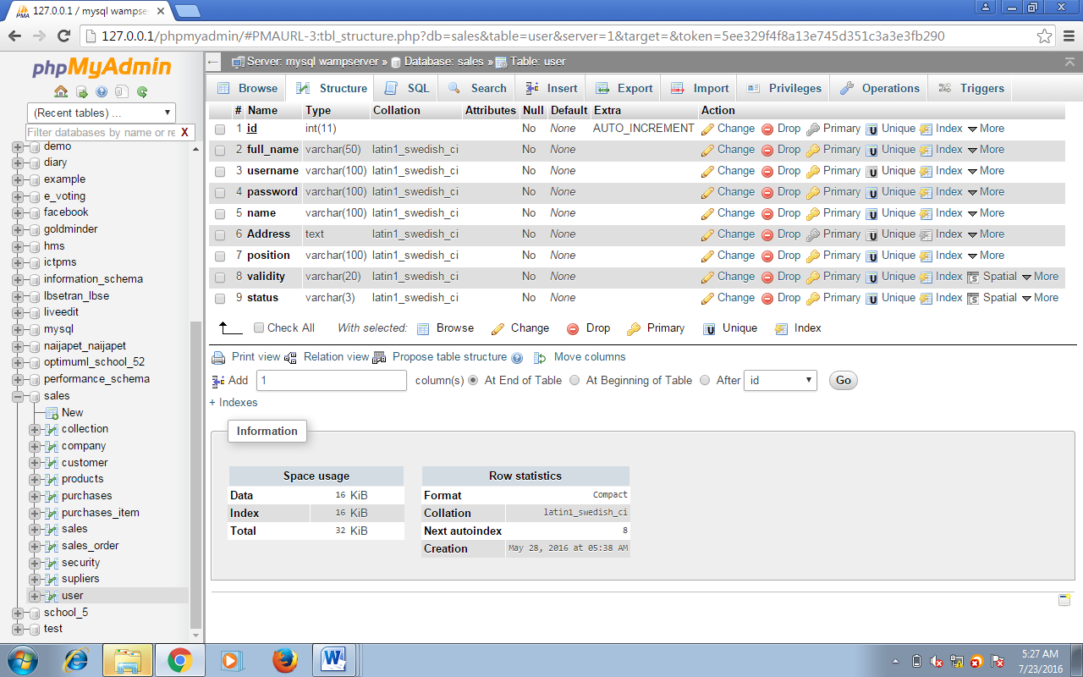**User Table:**

Id is Primary Key

**Security Table:**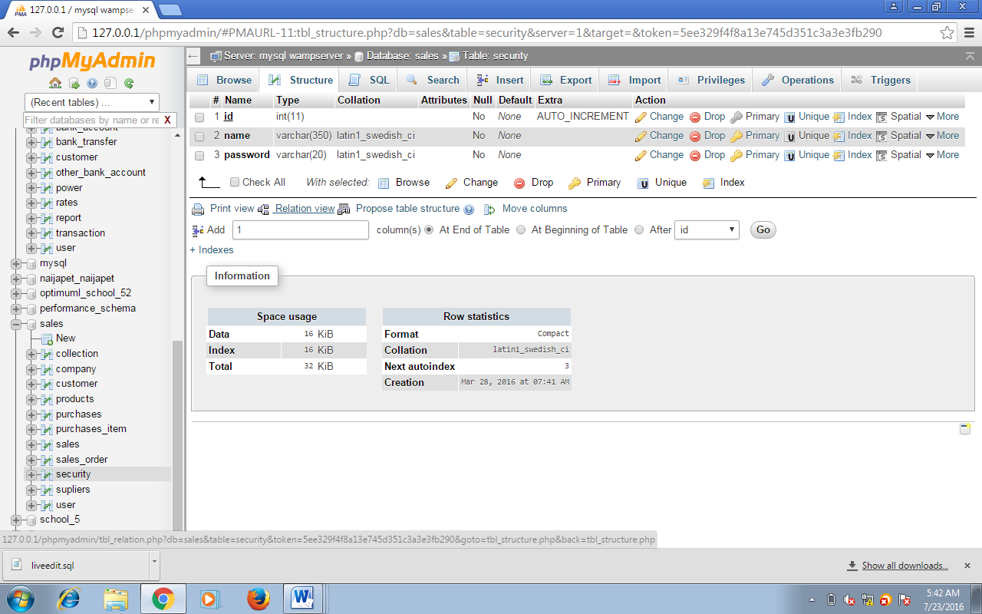

Id is Primary Key

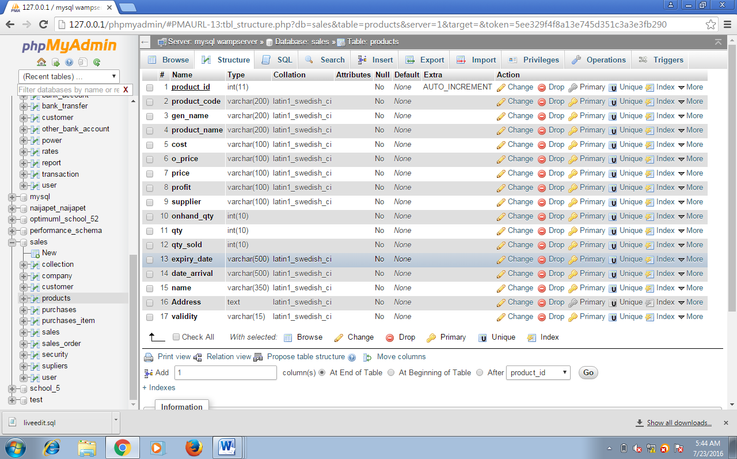**Product Table:**

Product id is the Primary Key

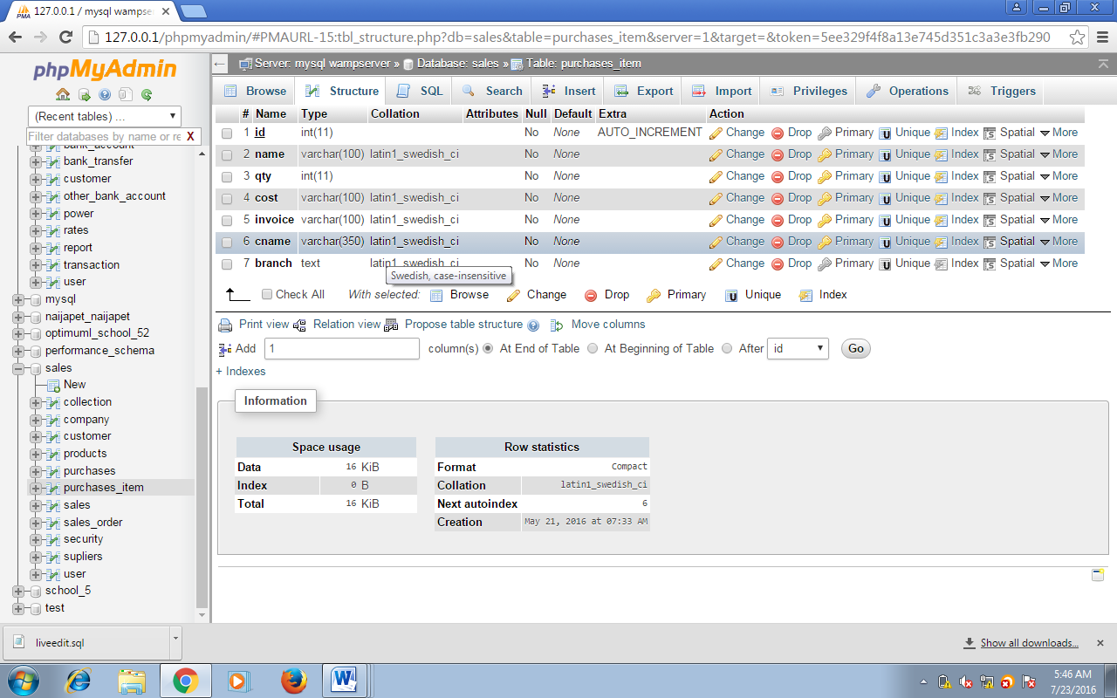**Purchases Item Table:**

Id is the primary key

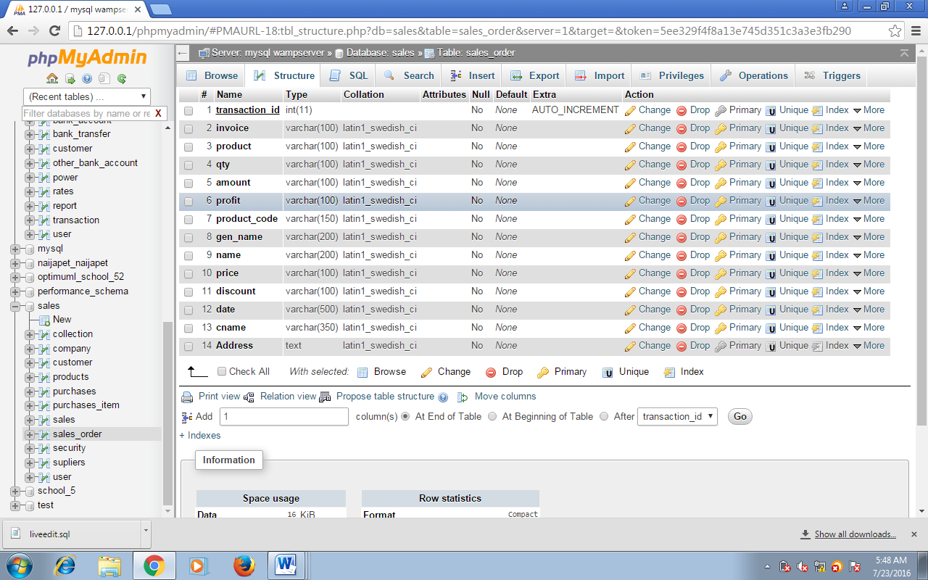**Sales Order Table:**

transaction id is the Primary key

**Sales Table:**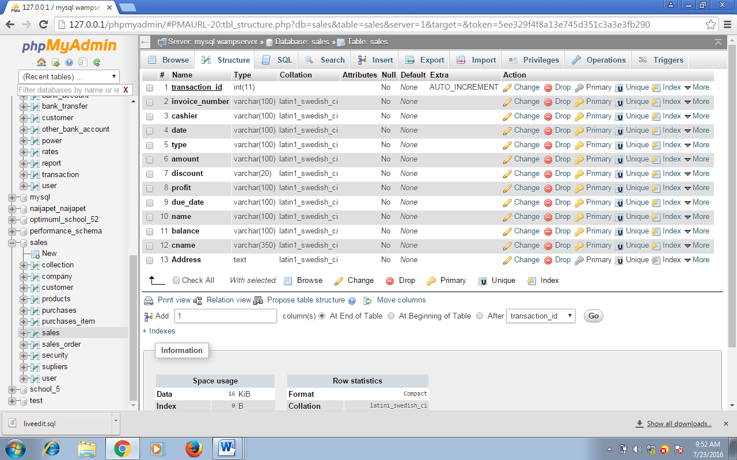

Transaction id is the primary key

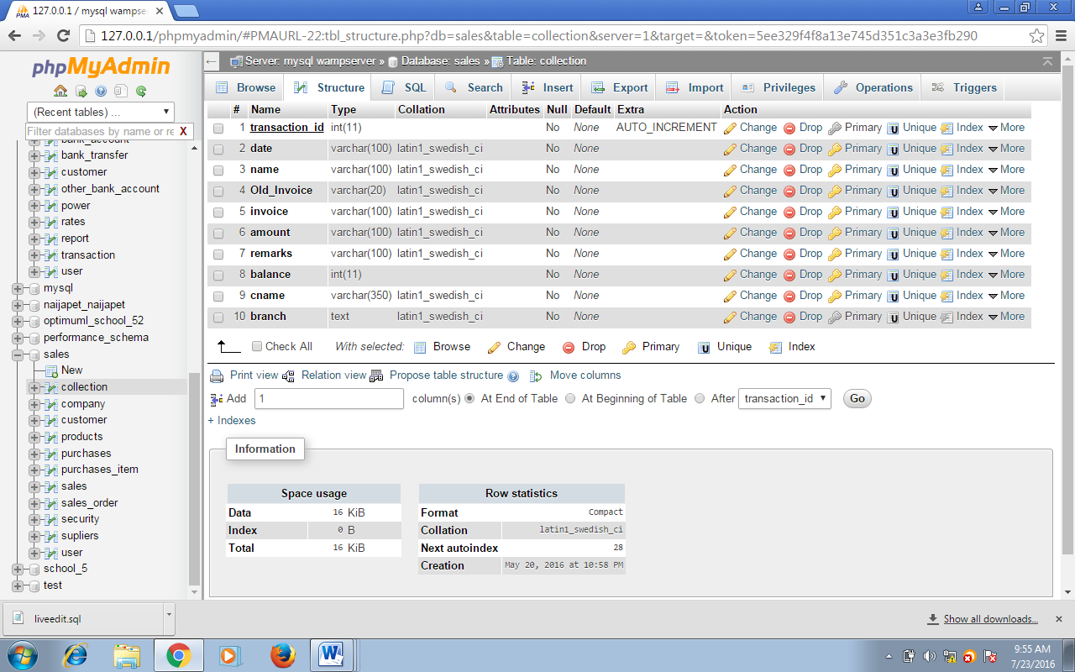**Collection Table for Debtors:**

Transaction id is the Primary key

The foreign key Transaction id which links to Collection Details Transaction id

## 3.9 Data base Tables/Quais Structure (Optionnel)

A Data Flow Diagram (DFD) is a graphical representation of the "flow" of data through an Information System. A data flow diagram can also be used for the visualization of Data Processing. It is common practice for a designer to draw a context-level DFD first which shows the interaction between the system and outside entities. This context-level DFD is then "exploded" to show more detail of the system being modeled.

A DFD represents flow of data through a system. Data flow diagrams are commonly used during problem analysis. It views a system as a function that transforms the input into desired output. A DFD shows movement of data through the different transformations or processes in the system.

data they input ultimately has an effect upon the structure of the whole system from order to dispatch to restock how any system is developed can be

determined through a data flow diagram. The appropriate register is saved in the database and maintained by appropriate authorities.

**Data Flow Diagram Notation**

. Function

File/Database

Input/ Output

Flow

**Data Flow Diagram of the Online POS Receipt Generating System**

**Level.0**

User/ Admin

Input

Out Put

**Admin login goes here**

**Level.1**

Admin

User

**Level2:UserModule:**

Purchase item

User

Add items

Update Quantity

Delete the items

Generate Receipt

**Level 3:**

**Admin Module:**

Add and view

Admin

# CHAPTER FOUR

# RESULT AND DISCUSSION

## 4.1 Introduction

Having heard and read all from chapter one about the old system and this new method that will be designed to restructure it. We have come to this chapter, the fourth chapter where the system will be developed and implemented. Also, before the end of this chapter, the source codes, sample output, web development, language development (selection), how to run the program, program source codes, hardware requirements and finally the documentation, all will be discussed in this chapter.

## 4.2 Source Codes

The source code to the Online POS Receipt Generating System, which was written using HTML for the front-end user interface, PHP server-side scripting language for the middleware application and MySQL for the design of the database, is provided at the appendix of this research project.

## 4.3 Sample Outputs

Shown below are the sample outputs of the newly proposed Online POS Receipt Generating System.

**Main Menu:** This is the homepage of the website that has been developed. The home page of any website is the first page that appears whenever you open a website. It contains the name of the site, logo as the case may be and other icons known as hyperlinks that will help you navigate to other areas. It also contains other hyperlinks made for free and easy access and use by even those that are not programmers. These hyperlinks can also be called web pages, when clicked links user to other resources.

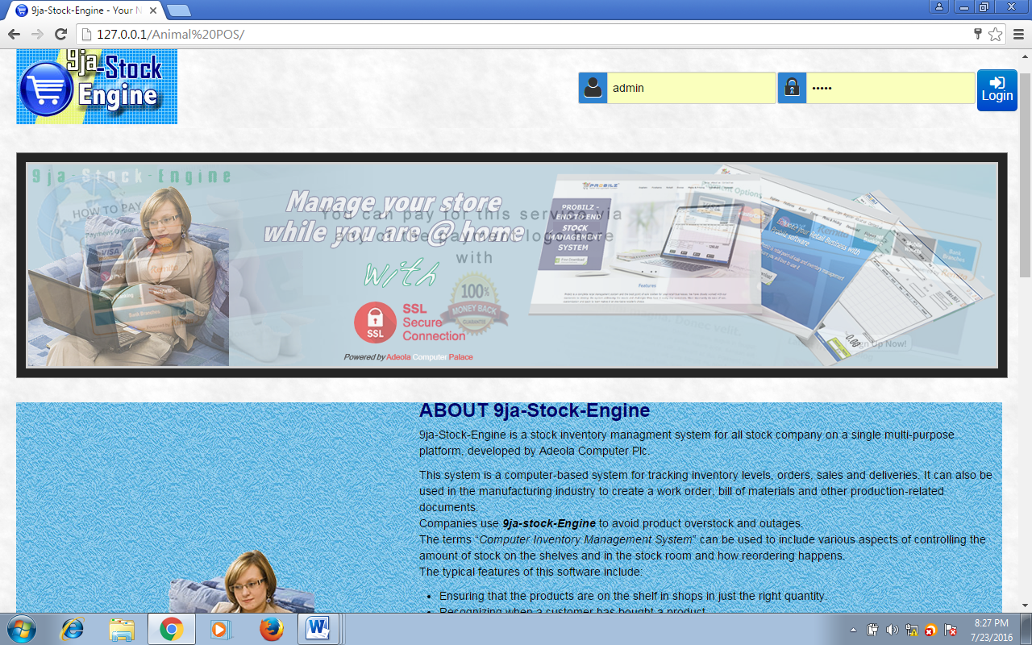

**Figure 4.1**

## 4.4 Web Development

Web as it is known is always associated with the spider. It is an intermingling of things, wires, ropes etc. Technologically, it is multiples of network connections, or network. The web was developed with the name of the firm, the reason for the website and other additions such as the functions of the firm. All these contributed to the development of this web.

## 4.5 Language Development/Selection

The language here in question is not the language spoken by human beings. The computer has a set of symbols, digits and instructions written in sequence known as programming language which the computer operator used to communicate with the computer. Here among the programming languages the one considered most suitable by the system developer/programmer and used to write the source program and the code was PHP). It was used due to its user friendliness and worthwhileness. Several reasons ride the choice of using PHP for this system, one of which is its extensive portability and use over several web host servers on the internet. Also PHP possesses several inbuilt functions which allow it to integrate well with the widely used and accepted database storage management system for the web-MySQL. Due to its wide use, several documentations are available online which will guarantee that materials about any aspect of its use will be easily found.

## 4.5 How to Run the Program

In order to effectively run the application, the following hardware and software requirements are required:

**Hardware Requirement:**

For proper installation of the system, the following minimum hardware requirements are:

1. Color Monitor

2. 512MB Random Access Memory (RAM Size)

3. 1 Gigabyte Hard Disk Drive

4. Network card (adapter)

5. Keyboard

6. Mouse

**Software Requirement**

The software requirements for the installation of the system are listed below:

1.Web Browser Software Application

2.Apache Web Server

3.MySQL Database Server

**Installation Procedure**

Some computer programs can be executed by simply copying them into a [folder](http://en.wikipedia.org/wiki/Folder_%28computing%29) stored on a computer and executing them but this is quit advanced in nature because of the advancement in technology. Other programs are supplied in a form unsuitable for immediate execution and therefore need an installation procedure. Once installed, the program can be executed again and again, without the need to reinstall before each execution.

The following are the step involve in settling up the online shopping website:

1. Install the wamp Server.

2. Copy the **Online POS** folder to your www directory

***Locating Root Folder.....Click on Computer....Click on Local disk c...navigate to wamp.....Click on www…..paste the folder......***

3. Import the database file through **phpMyAdmin** in wamp server

4. Launch your browser

5. Type **localhost** or **127.0.0.1** in the address bar.

6. Click on **Online POS**

## 4.6 System Implementation

This chapter is the part that puts a planned system into action and examines in detail the analysis and design of the Online POS Receipt Generating System. The present chapter discusses the implementation of the system, highlighting the testing exercise and describing some of the main components of the system's Graphical User Interface. It will give an output from the programming language and other tools used to develop our system. According to this plan, the activities are to be carried out, discussions made regarding the equipment and resources and the additional equipment has to be acquired to implement the new system.

The following section explains the functionality of the various modules of the Online POS Receipt Generating System.

**System Login Page:**

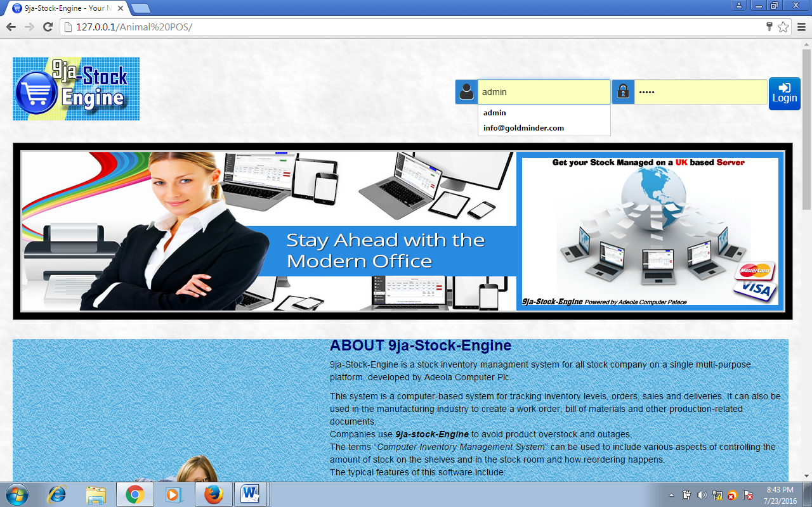

**SYSTEM CUSTOMER REGISTRATION PAGE:**

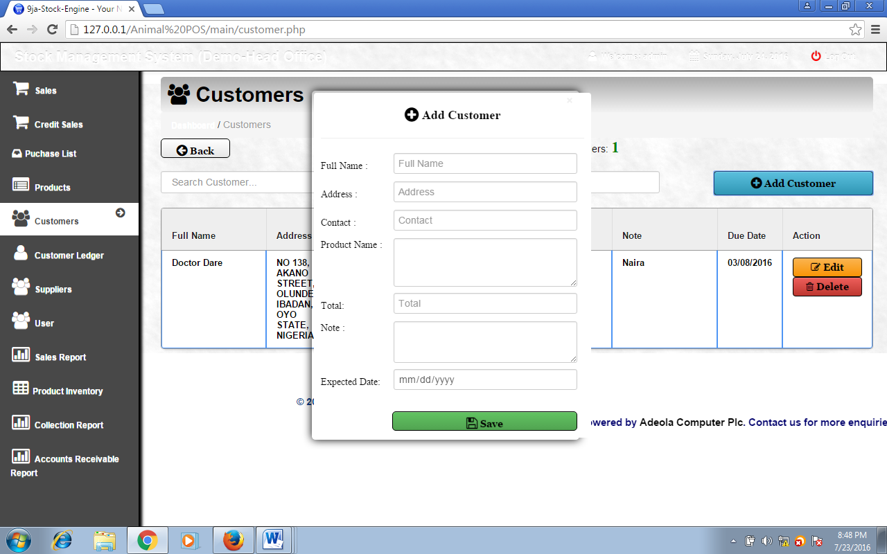

**Figure 4.2**

This form lets the users of the system submit login details to gain access into the system.

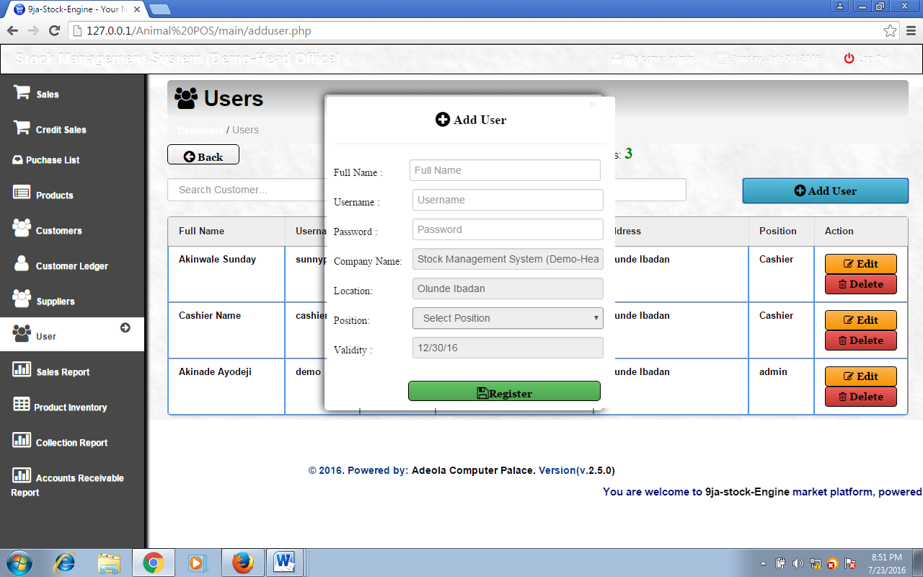**System User Registration Page:**

**Figure 4.3**

This form lets the users of the system (admin) register new regular customers for proper recording.

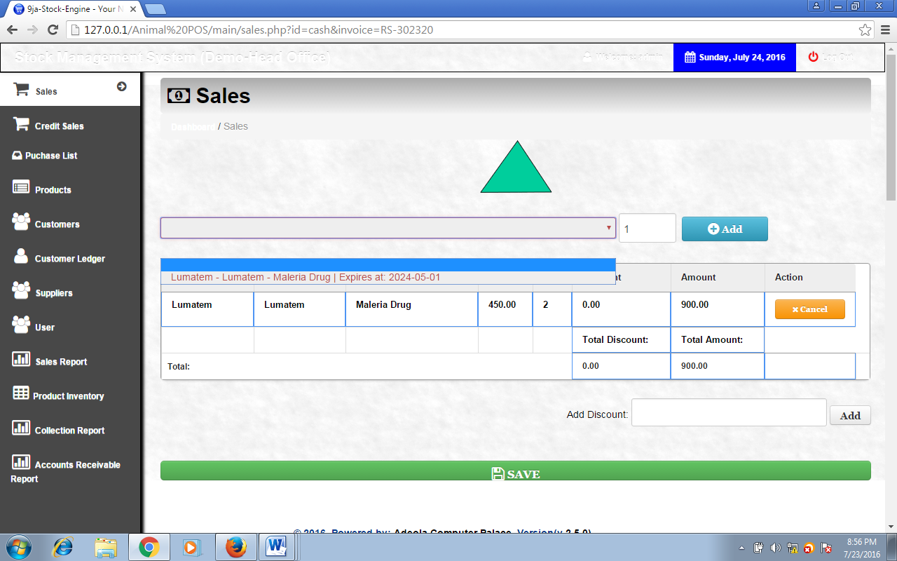**System Sales Page:**

**Figure 4.4** This form lets the admin register the user’s details in order to gain access into the system.

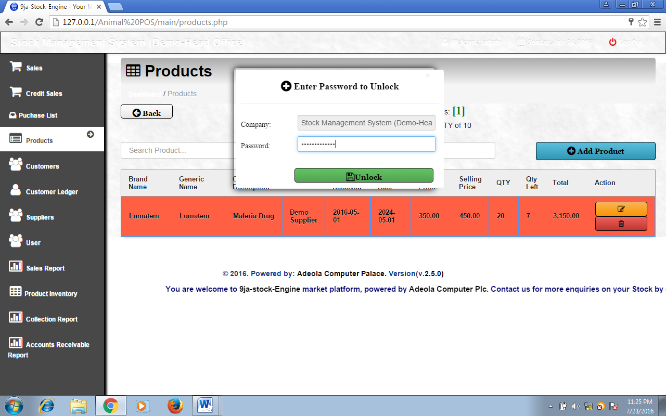**System Products Page:**

**Figure 4.5**

This is where sales record is being processed by the user/admin.

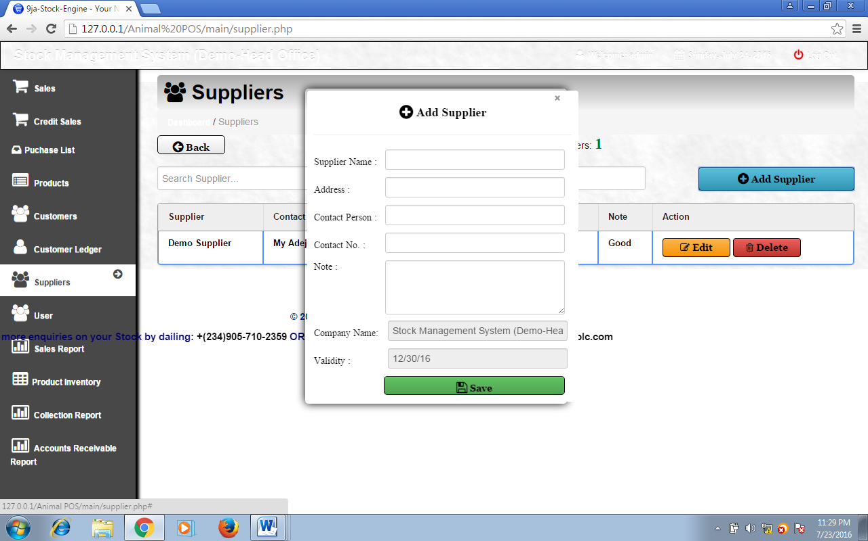**System Supplier Page:**

**Figure 4.6**

Here on this page, the admin can view the available product quantity, add more product, edit product details and the likes.

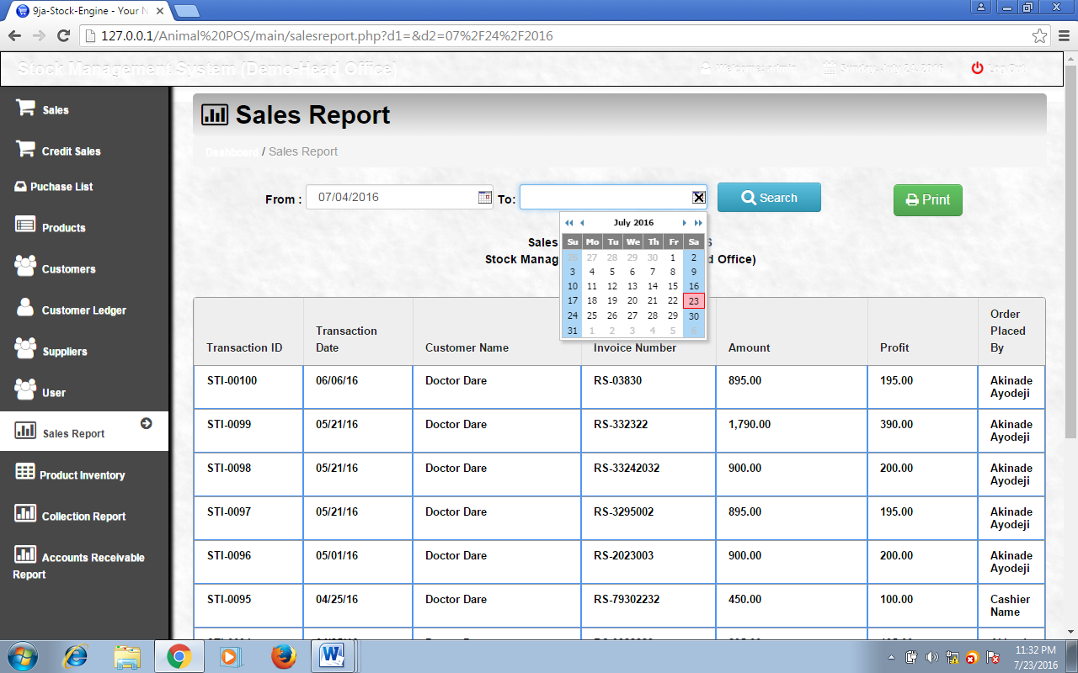**System Report Page:**

**Figure 4.7**

Here on this page, the admin as the right to add supplier, view supplier details, edit supplier details and the likes.

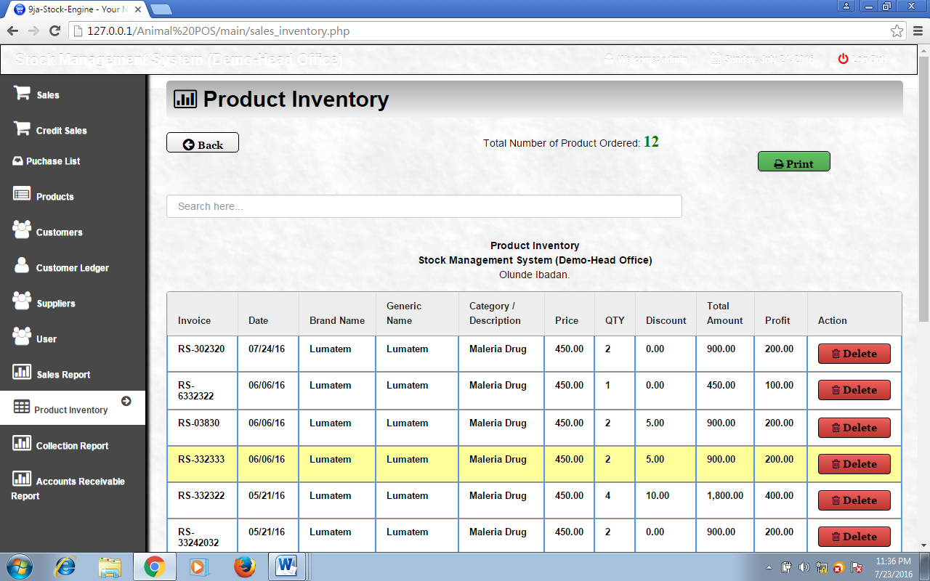**Sales Report:**

**Figure 4.8**

This is where the report of the sales ordered by the customer is being generated by picking the date **From:** *e.g 07/04/2016* **To:** *e.g 07/23/2016.*

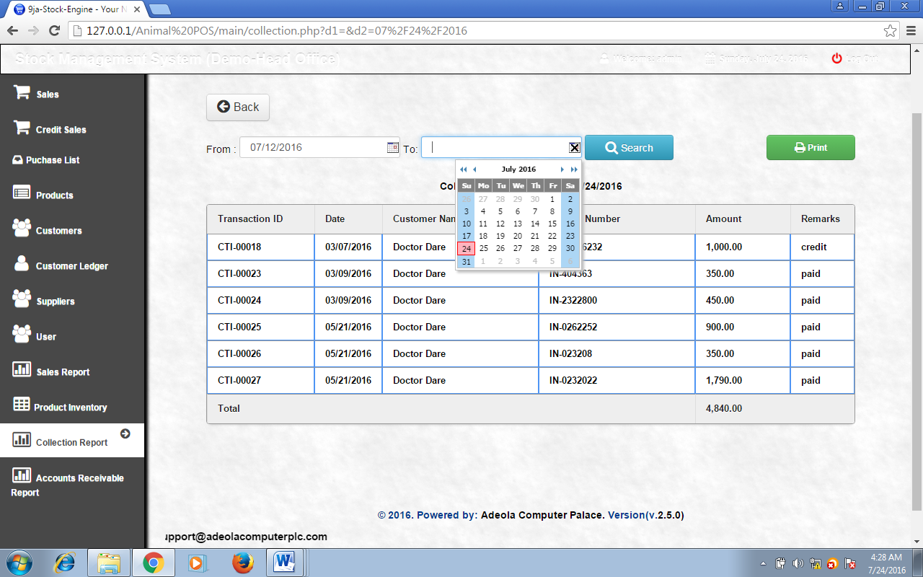**System Collection Page:**

**Figure 4.9**

This is where all product sold by the cashier is being stored with total discount, profit and amount column

## 4.6 System Maintenance

The program may be maintained on the ground that the system requires an upgrade. When there is a new field to be added or a new form to be added in order to serve users well.

**The following precaution should be done**

i. Ensure that the computer is kept in clean areas.

ii. System should be kept in cool places.

Iii. Air conditioner is important to reduce room temperature and keep it constant.

iv. Backup of data is important

**4.5 System Evaluation**

This System is a high standard program that can weather the storm of technology advancement, it is most needed in all sales shop and it is an antidote for poor business speed and transaction with record keeping and maintenance, it will be very helpful to clients and customers in the marketing business. All it needs is a computer literate operative to make it work; it is web base and automated

# CHAPTER FIVE

# SUMMARY, CONCLUSSION AND RECOMMENDATIONS

## 5.1 Introduction

An adage says that every beginning has an end. With everything being under total submission to nature, we have finally arrived at the last chapter of this project work, this chapter discusses in brief all that have been said in the first, second third, fourth, and the fifth chapters. Also included are the summary, conclusions and recommendation parts of this chapter.

## 5.2 Summary

On-line cash receipt generating system a unit of E-commerce is a website that will synthesize and increase the functionality of product sales. Although a lot of websites have been designed and hosted to achieve a lot of goals in different businesses, this one exclusively designed for Rorban supermarket will go a long way in boosting and unveiling the fortunes of the supermarket, and their method of operation which has not yielded sufficient profit as expected.

This is what the web designer/developer noticed and took up as a topic. All the steps starting from the first chapter are all designed to make the application project come through. For future references and modifications, the source code is also included showing the language steps used to design the application.

## 5.3 Conclusion

In conclusion, this is a user friendly application designed for on-line buying and selling of products with the capabilities of generating receipts using a POS thermal printer. It is a site that inculcates the new web technology in its full design. When this is fully implemented it will promote and improve the standard of operations of the supermarket which is entirely manual. Furthermore, as the whole wide world walks towards living in a global community, the supermarket will now fit into the global market community and be recognized. The inconveniences faced by our customers and unsatisfactory turnover will now be history.

## 5.3 Recommendations

Having presented all that is required for the successful implementation of this project research work, the following are suggested by the programmer aimed at improving and eliminating the problems encountered each day by both customers and the management. The measures are as follow;

1. The server should be managed by a database administrator who has undergone training on using the MYSQL database.
2. There should be a regular update of the application so as to compete and give round the clock service to the people.
3. There should be no hesitation in attending to the needs of the new system designed.

# REFERENCES

"A guide for businesses on distance selling" (PDF). Office of fair trading 2004. Retrieved 19 March, 2014.

Christopher M. and Chris F. K’s (2002)

Falk, Louis K.; Sockel, Hy; Chen, Kuanchin. (2005) "E-Commerce and Consumer's Expectations: What Makes a Website Work." Journal of Website Promotion, 1(1) (65–75).

Geena Rao (July 19, 2010). "Mopay Now Allows You To Bill Mobile Payments To A Landline Account" . TechCrunch.com. Retrieved 23 November 2010.

I. Wallis (2011) ed ’50 Best Business Ideas [of the last 50 years]’ Crisom Publishing, p35 ISBN 978-1-85458-671-1 ‘Entrepreneur Michael Aldrich conceived the idea of e-commerce’’Dictionary.law.com. 2010-12-09. Retrieved 2013-09-03.

Microsoft Encarta premium (2009) Internet Access technological

Oxford Advanced Learners Dictionary

PCI Security Standards Council. "PCI Data Storage Do’s and Don’ts" (PDF). Retrieved 24 March 2013.

Steve Elliot and Sue Fowell, "Expectations versus reality: a snapshot of consumer experiences with Internet retailing", International Journal of Information Management 20 (2000): 323–336

(Christopher), according to kiely T. (1997), online shoping is the buying and selling of things (oxford Advance learner’s Dictionary)

Rani kalacota (1997) defined on-line shopping as part of an on-line business

And chris F. K (1994) defined on-line shopping as the process of managing on-

working and internationally organized on-line. PCI Security Standards Council. "PCI Data Storage Do’s and Don’ts" (PDF). Retrieved 24 March 2013.